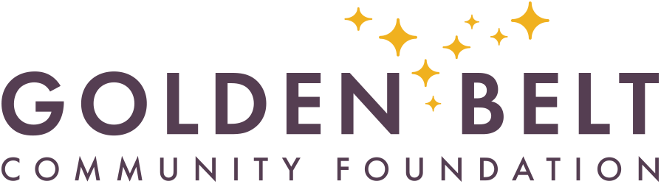
For Immediate Release:
www.goldenbeltcf.org

June 30, 2026

GOLDEN BELT COMMUNITY FOUNDATION
2026 YOUTH GRANT OPPORTUNITY

GREAT BEND, Kan.
Golden Belt Community Foundation invites proposals for its upcoming competitive grant cycle focused on the health and well-being of youth, funded through the Kansas Health Foundation Youth Endowment and the Children’s Endowment. These funds support the health and well-being of youth and include, but are not limited to, enhancements to public play spaces, educational projects, recreation, safety, nutrition, and physical activity.

Applications are now being accepted from qualified 501(c)(3) non-profit organizations and public institutions, including schools, government entities, and other charitable organizations in Barton, Pawnee, Rush, and Stafford counties.

Applications are available online by clicking the Grants link on the foundation website at www.goldenbeltcf.org. Grant guidelines also are posted on the website. If you have any questions, please contact the GBCF office.

Applications must be received by Friday, July 31st. Grants will be awarded by mid-September. For questions about grants, please contact Teresa Powelson, Program Officer at 620-792-3000 or email teresa@goldenbeltcf.org.

Golden Belt Community Foundation
At over $43 million in total assets and more than 180 funds under management, Golden Belt Community Foundation has been connecting people who care to causes that matter since 1996. Golden Belt Community Foundation exists to provide non-profit organizations in central Kansas with a permanent source of support and to serve as a vehicle for charitable giving for donors. GBCF serves the counties of Barton, Pawnee, Rush, and Stafford. For more information about Golden Belt Community Foundation, call (620) 792-3000 or visit their website at www.goldenbeltcf.org.
###

